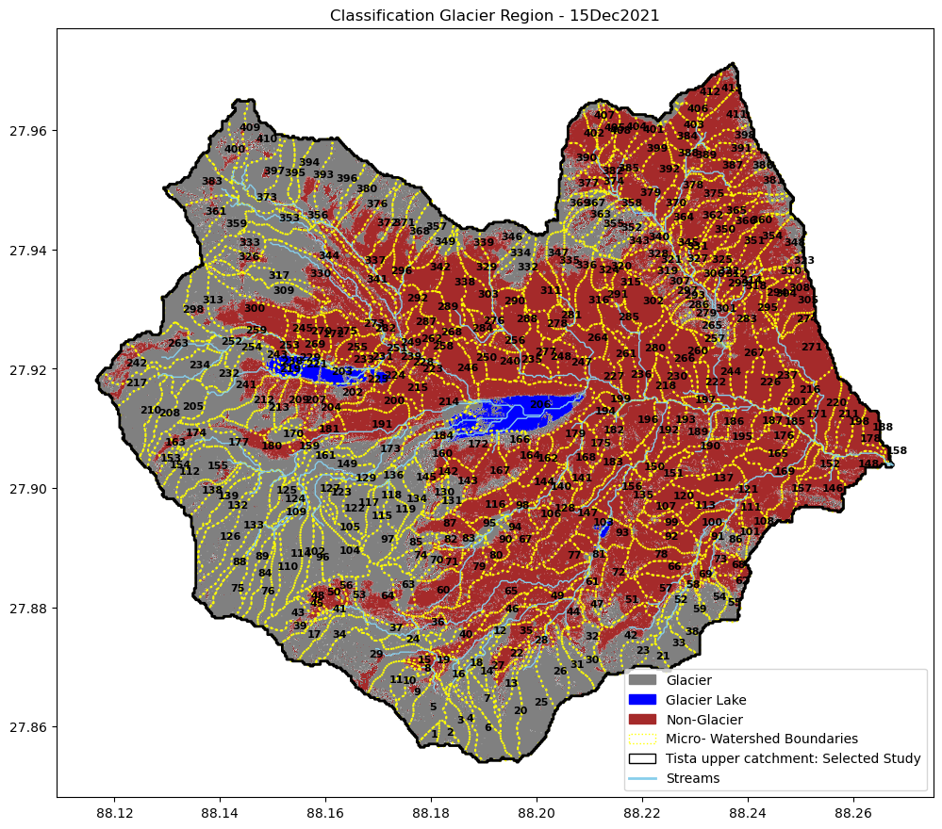
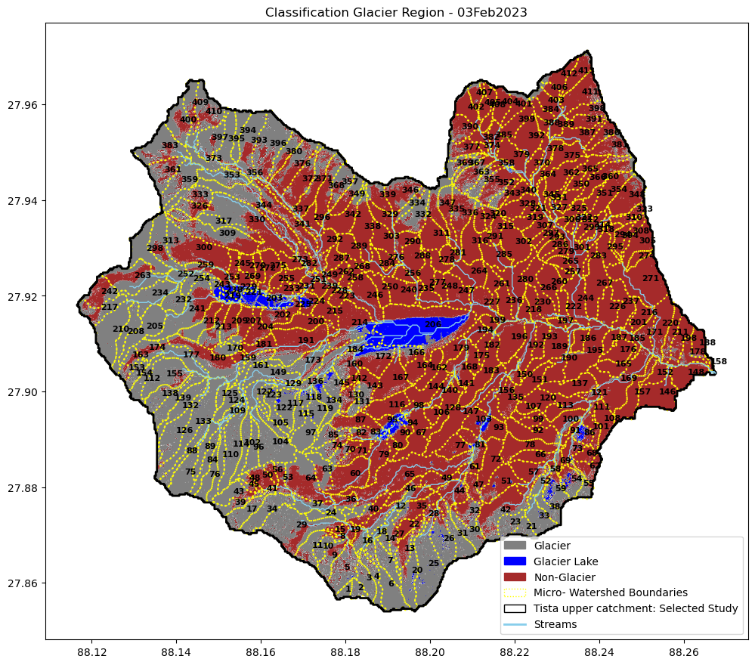

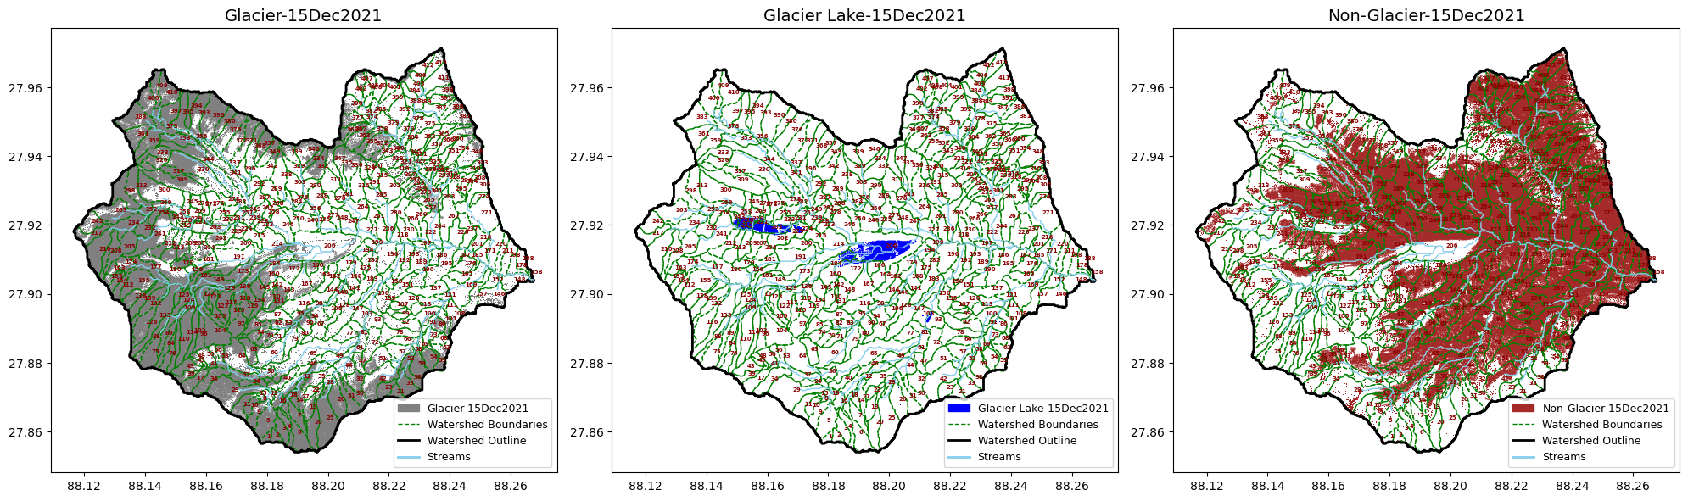
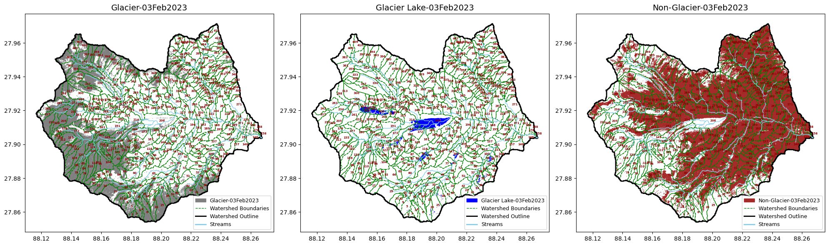

Glacial Morphometry

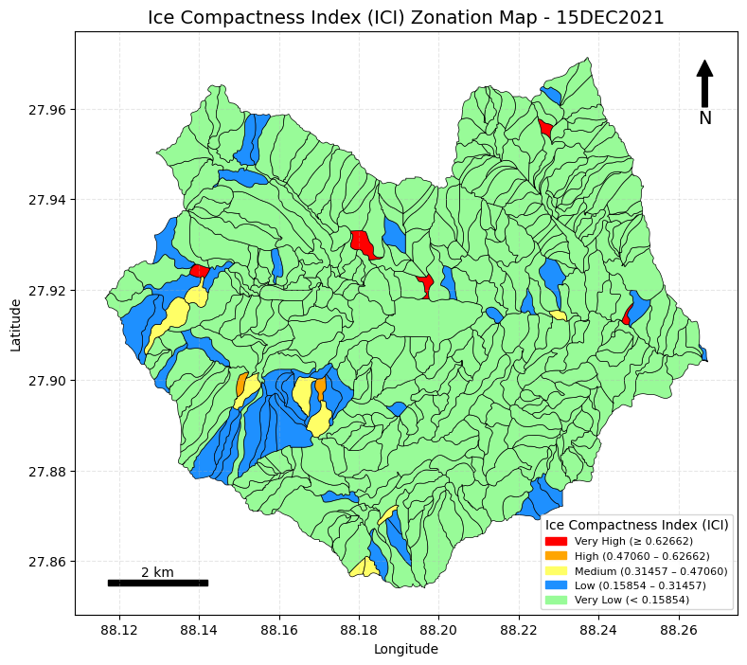  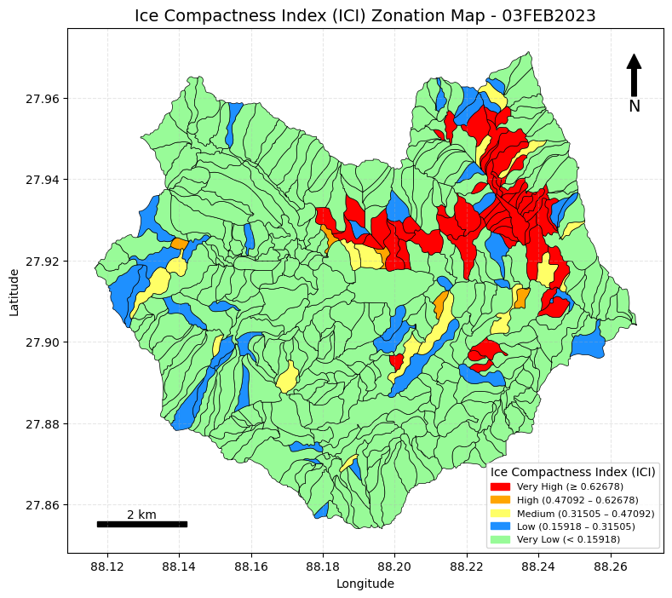 | Step1: Compute Glacier Area and Perimeter  Input: glacier.geojson  Output: glacierAP.geojson  Algorithms  - Read the input glacier GeoJSON file.  - Reproject the glacier data to a projected CRS to ensure correct area and perimeter calculations.  - Compute glacier area in square meters (m²).  - Convert glacier area from m² to km².  - Compute glacier perimeter in meters (m).  - Convert glacier perimeter from meters to kilometers (km).  - Round all computed area and perimeter values to three decimal places.  - Save the output GeoJSON with the new attribute fields:  - Area_m2  - Area_km2  - Perimeter_m  - Perimeter_km  Step2: Compute Ice Compactness Index (ICI) for Each Glacier Segment  Input: glacierAP.geojson  Output: glacierICI.geojson  Algorithms  - Read the glacier GeoJSON file containing area and perimeter attributes.  - Ensure that Area and Perimeter columns exist in the dataset.  - Merge (dissolve) all glacier polygons based on W_ID.  - Recalculate Area and Perimeter for each merged Micro-watershed.  - Compute the Ice Compactness Index (ICI) for each Micro-watershed using:  - ICI = 4*Pi*Area / Perimeter2  - Save the output GeoJSON with the following attributes:  - W_ID  - Area_m2  - Perimeter_m  - ICI  Step3:Attached ICI Index with Micro-watershed  Input:  - glacierICI.geojson  - watershed_UTista_selected_WID.geojson  Output: glacierICI_W.geojson  Algorithms  - Read the glacier ICI GeoJSON file.  - Read the Micro-watershed GeoJSON file.  - Ensure both datasets use the same CRS.  - Perform an attribute join using W_ID.  - Retain the original Micro-watershed geometry and add the ICI-related attributes.  - Save the merged dataset as glacierICI_W.geojson.
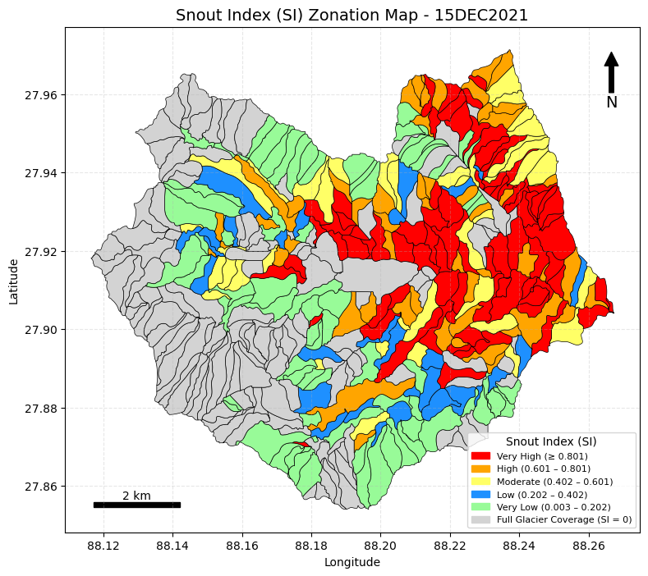  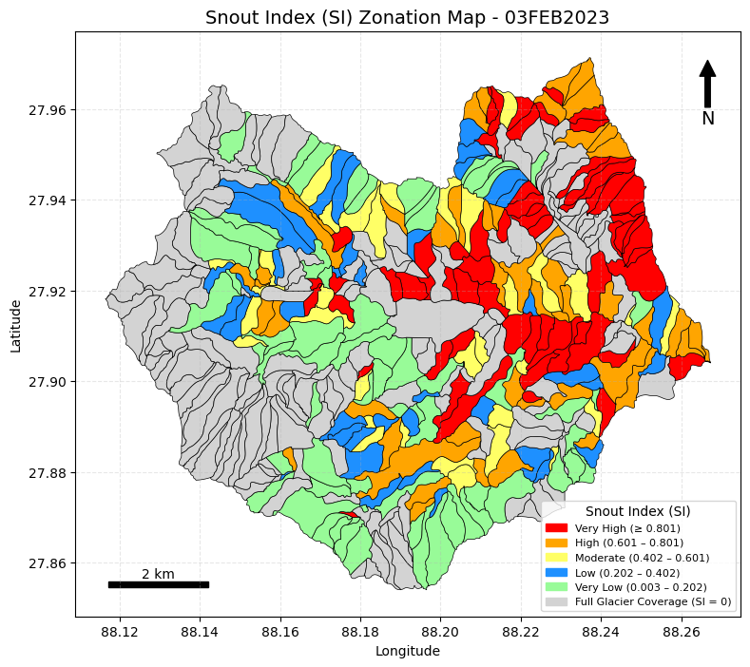 | Step 1: Extract Maximum Glacier Region per Micro-Watershed  Input: glacierAP.geojson  Output: glacier_max.geojson  Algorithms  - Read the glacier GeoJSON file.  - Ensure the CRS is projected for correct area computation in square meters.  - Compute glacier area in m² and km².  - Verify that the watershed identifier W_ID exists.  - Identify the glacier polygon with the maximum area within each micro-watershed.  - Save the output GeoJSON with the following attributes:  - W_ID  - Area_m2  - Area_km2  - geometry  Step 2: Extract Elevation for Each Vertex of Glacier Geometric Region  Input:  - GLOFDEM.tiff  - glacier_max.geojson  Output: vert_elev_glacier.geojson  Algorithms  - Read the glacier GeoJSON file.  - Open the DEM (GLOFDEM.tiff).  - Loop through each glacier polygon.  - Extract watershed ID and glacier ID.  - Handle MultiPolygon geometries.  - Extract vertices from the exterior ring of each polygon.  - Sample DEM elevation at each vertex location.  - Create a GeoDataFrame containing vertex geometry and elevation.  - Save the output as vert_elev_glacier.geojson.  Step 3: Extract Minimum (Snout) and Maximum Glacier Elevation Points  Input: vert_elev_glacier.geojson  Outputs:  - snout_points.geojson  - max_glacier_points.geojson  Algorithms  - Read the glacier vertex–elevation GeoJSON.  - Remove invalid or missing elevation values.  - Calculate the minimum elevation (snout elevation) per watershed.  - Save the snout elevation points.  - Calculate the maximum glacier elevation per watershed.  - Save the maximum glacier elevation points.  Step 4: Extract Elevation for Each Vertex of Micro-Watershed Geometry  Input:  - GLOFDEM.tiff  - watershed_UTista_selected_WID.geojson  Output: vert_elev_watershed.geojson  Algorithms  - Read the watershed GeoJSON file.  - Open the DEM (GLOFDEM.tiff).  - Loop through each watershed feature.  - Handle different geometry types.  - Extract coordinates from each geometry:  - Polygon → use exterior coordinates  - Sample DEM elevation at each vertex.  - Create a GeoDataFrame with vertex geometry and elevation.  - Save the output as vert_elev_watershed.geojson.  Step 5: Extract Minimum and Maximum Elevation Points for Micro-Watershed  Input: vert_elev_watershed.geojson  Outputs:  - min_watershed_points.geojson  - max_watershed_points.geojson  Algorithms  - Read the watershed vertex–elevation GeoJSON.  - Remove invalid or missing elevation values.  - Calculate the minimum watershed elevation per watershed.  - Save the minimum elevation points.  - Calculate the maximum watershed elevation per watershed.  - Save the maximum elevation points.  Step 6: Print Attribute Columns  Inputs:  - watershed_UTista_selected_WID.geojson  - snout_points.geojson  - max_glacier_points.geojson  - min_watershed_points.geojson  Algorithms  - Read all input GeoJSON files.  - Use a function to print attribute columns only.  - Print attribute columns for each dataset.  Step 7: Compute Snout Index (SI)  Inputs:  - watershed_UTista_selected_WID.geojson  - snout_points.geojson  - max_glacier_points.geojson  - min_watershed_points.geojson  Output: snout_index.geojson  Algorithms  - Read all input GeoJSON files.  - Ensure CRS consistency across datasets.  - Retain only required attribute fields.  - Merge datasets using W_ID.  - Compute Snout Index (SI) using:  SI=Esnout−Emin / Emax−Emin  - Save the output as snout_index.geojson.
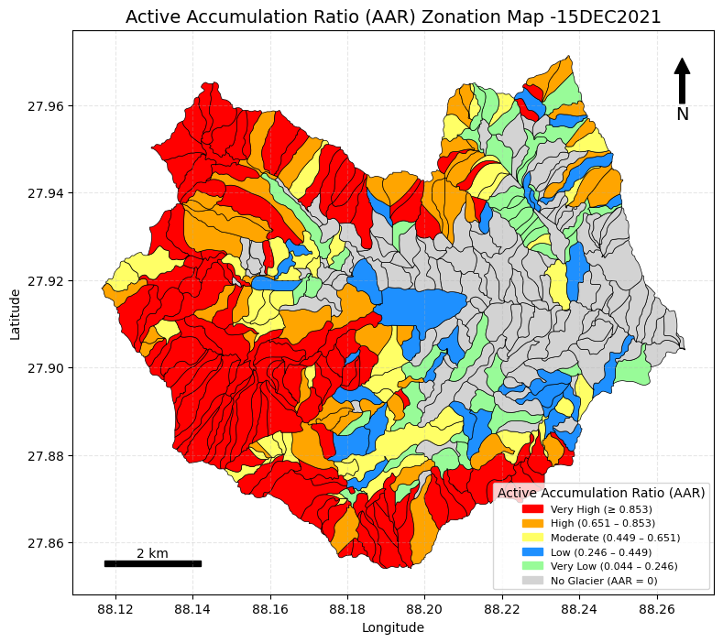  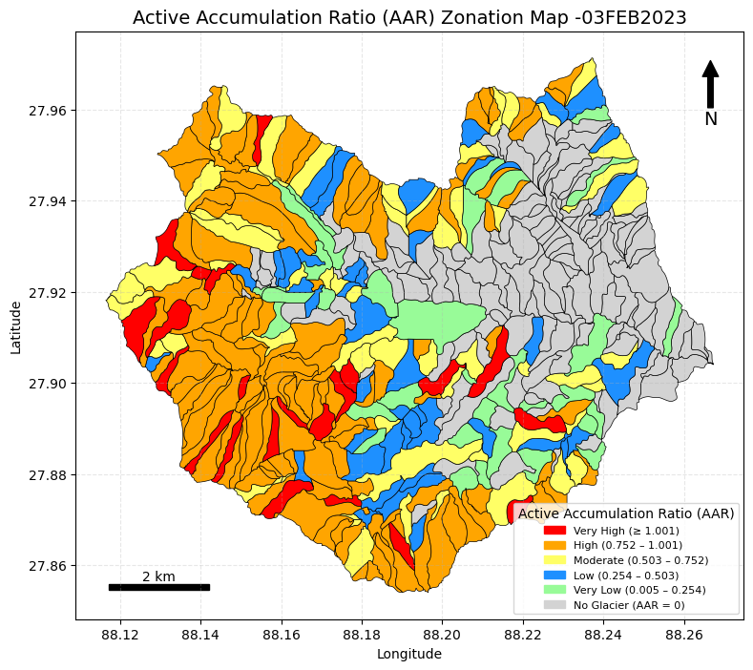 | Step 1: Extract Maximum Glacier Region per Micro-Watershed  Input: glacierAP.geojson  Output: glacier_max.geojson  Algorithms  - Read the glacier GeoJSON file.  - Ensure the CRS is projected for accurate area computation in square meters.  - Compute glacier area in m² and km².  - Verify that the watershed identifier W_ID exists.  - Identify the glacier polygon with the maximum area within each micro-watershed.  - Save the output GeoJSON with the following attributes:  - W_ID  - Area_m2  - Area_km2  - geometry  Step 2: Extract Equilibrium Line Altitude (ELA) Contour Line per Micro-Watershed  Input:  - GLOFDEM.tiff  - glacier_max.geojson  - watershed_UTista_selected_WID.geojson  Output: ELA_lines_longest.geojson  Algorithms  - Load the DEM, glacier maximum area polygons, and watershed GeoJSON files.  - Fix invalid geometries where required.  - Ensure all datasets use the same CRS.  - Define a function to compute ELA from the DEM.  - Define a function to extract ELA contour lines.  - Retain only the longest ELA contour line for each micro-watershed.  - Iterate through each watershed using the actual W_ID.  - Save the extracted longest ELA contour lines as a GeoJSON file.  Step 3: Identify Snow Accumulation Zone (SAZ)  Input:  - GLOFDEM.tiff  - glacier_max.geojson  - ELA_lines_longest.geojson  Output: SAZ_all_glaciers.geojson  Algorithms  - Read all input datasets.  - Merge ELA values into glacier polygons using W_ID.  - Read the DEM and mask NoData values.  - Ensure glacier polygons match the DEM CRS.  - Process each glacier polygon individually:  - Mask the DEM using the glacier polygon.  - Create a Snow Accumulation Zone (SAZ) mask.  - Convert the SAZ mask to polygon features.  - Combine SAZ polygons for all glaciers.  - Save the output as SAZ_all_glaciers.geojson.  Step 4: Extract Maximum Snow Accumulation Zone per Micro-Watershed  Input: SAZ_all_glaciers.geojson  Output: Accumulation_glaciers_max area.geojson  Algorithms  - Read the SAZ GeoJSON file.  - Check and fix the CRS if required.  - If the CRS is geographic (degrees), reproject to a projected CRS (e.g., UTM).  - Compute the area of each SAZ polygon.  - Extract the maximum area SAZ polygon per micro-watershed using W_ID.  - Save the output GeoJSON.  Step 5: Extract Entire Glacier Region per Micro-Watershed  Input: glacier.geojson  Output: glaciers_Entirearea.geojson  Algorithms  - Read the glacier GeoJSON file.  - Check and fix the CRS.  - If the CRS is geographic (latitude/longitude), reproject to a projected CRS suitable for area computation.  - Merge (dissolve) glacier polygons by W_ID to represent the entire glacier region per micro-watershed.  - Save the output GeoJSON.  - Confirm that glacier polygons are successfully merged by watershed.  Step 6: Compute Glacier Active Accumulation Ratio  Input:  - watershed_UTista_selected_WID.geojson  - Accumulation_glaciers_max area.geojson  - glaciers_Entirearea.geojson  Output: accumulation_ratio.geojson  Algorithms  - Read all input GeoJSON files.  - Ensure CRS consistency across all datasets.  - Retain only non-geometry attribute columns required for joining.  - Rename area columns for clarity prior to merging.  - Merge all datasets using the watershed identifier W_ID.  - Compute the Accumulation Area Ratio (AAR / AAA).  - Save the output GeoJSON with the following attributes:  - W_ID  - Accum_Area_sqm  - Glacier_Area_sqm  - AAR
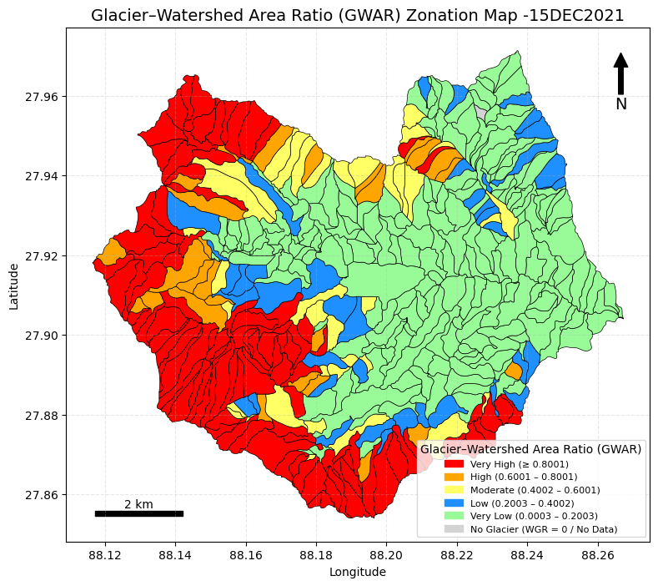  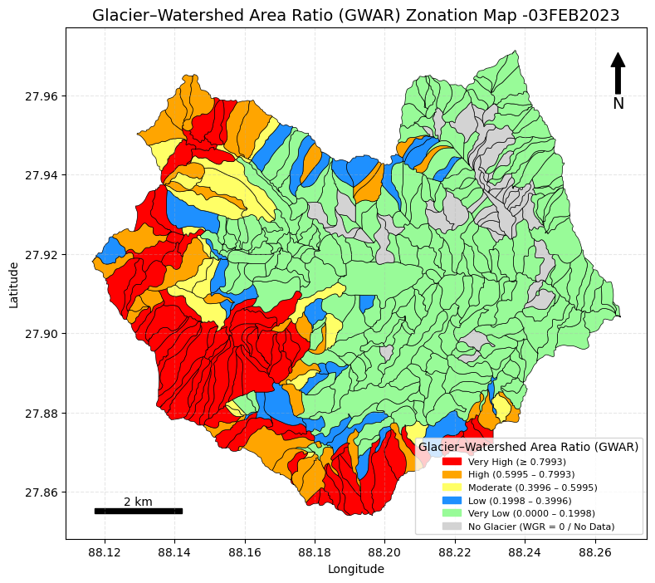 | Step 1: Intersection of Micro-Watershed Region with Glacier Region and Area Computation  Input:  - watershed_UTista_selected_WID.geojson  - glacier_max.geojson  Output: watershed_glacier_area.geojson  Algorithms  - Read the Micro-watershed boundary GeoJSON file.  - Read the maximum glacier coverage GeoJSON file.  - Check whether both layers use the same CRS.  - If the CRS differs, reproject the glacier layer to match the CRS of the Micro-watershed layer.  - Rename the watershed identifier field to prevent naming conflicts:  - W_ID → WID_MAIN.  - Compute the area of each micro-watershed in square meters (sqm).  - Perform a spatial intersection between the glacier layer and the micro-watershed layer.  - Compute the glacier area for each intersected micro-watershed segment.  - Group the segmented glacier regions by WID_MAIN.  - Sum the glacier area values for each micro-watershed.  - Merge the glacier segments accordingly for each watershed.  - Rename the watershed identifier field back to:  - WID_MAIN → W_ID.  - Save the output GeoJSON as watershed_glacier_area.geojson.  Step 2: Compute Glacier–Watershed Area Ratio (GWAR)  Input: watershed_glacier_area.geojson  Output: WGR.geojson  Algorithms  - Read the input GeoJSON file.  - Check that all required columns exist.  - Compute the Glacier–Watershed Area Ratio (GWAR) as: GWAR=Glacier Area/Watershed Area  - Optionally replace NaN or infinite values with zero.  - Save the output GeoJSON as WGR.geojson
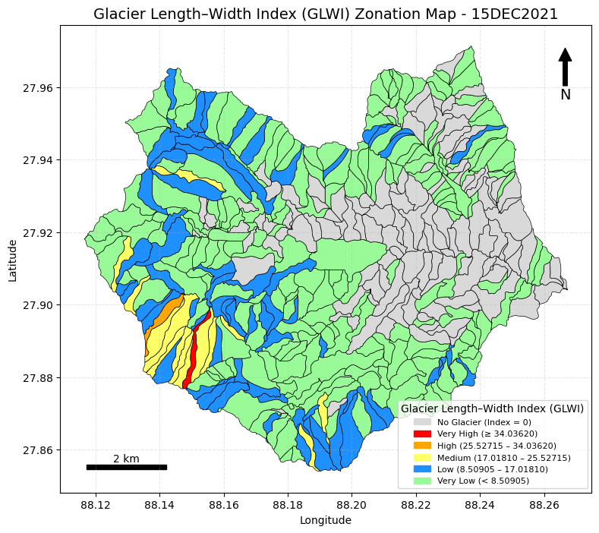  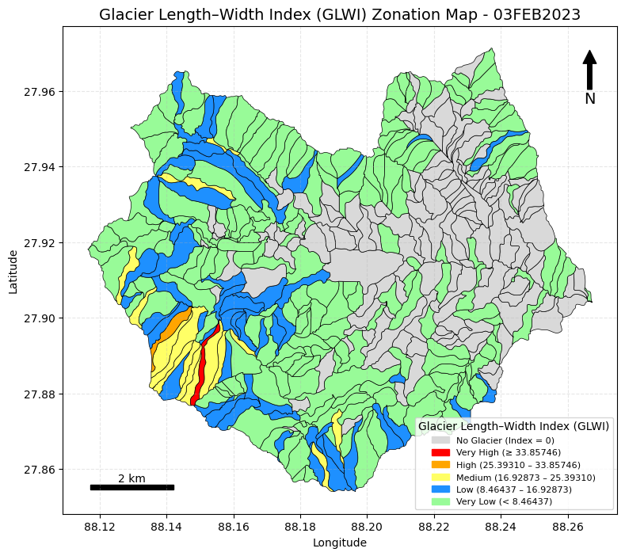 | Algorithm: Glacier–Watershed Length–Width Parameters & GLWI (GEQ)  Step 1: Assignment of Multiple Width Lines for Each Micro-Watershed  Input: watershed_UTista_selected_WID.geojson  Output: watershed_width_WID.geojson  - Read micro-watershed boundary file  - Ensure CRS is projected (meters)  - Define parameters  - Number of points along main axis  - Length of perpendicular width lines (meters)  - Extract maximum length (main axis) line  - Generate perpendicular width lines along the axis  - Intersect width lines with watershed polygon  - Select longest intersection as width at each position  - Compute mean width per watershed  - Store results: W_ID, axis line, width lines, mean width  Step 2: Extraction of Glacier Width Lines per Micro-Watershed  Input: watershed_width_WID.geojson,  Output: watershed_width_clipped_glacier.geojson glacier_max.geojson  - Read watershed width lines and glacier polygons  - Ensure CRS consistency (meters)  - Overlay (intersection) width lines with glacier polygons  - Retain only line segments inside glaciers  Step 3: Compute Mean Width for Micro-Watershed  Input: watershed_width_WID.geojson  Output: watershed_widthmean.geojson  - Read width line data  - Compute length of each width line  - Calculate mean width per W_ID  - Attach mean width to lines or keep one representative line  Step 4: Compute Mean Width for Glacier  Input: watershed_width_clipped_glacier.geojson  Output: glacier_widthmean.geojson  - Read clipped glacier width lines  - Compute length of each line  - Calculate mean glacier width per W_ID  - Attach mean width or retain representative line  Step 5: Compute Glacier Length per Micro-Watershed  Input: Wcenterline_length.geojson,  glacier_max.geojson  Output: watershed_length_clipped_glacier.geojson  - Read glacier centerline and glacier polygon  - Ensure CRS consistency  - Overlay (intersection) centerline with glacier polygon  - Clip centerline segments by W_ID  Step 6: Compute Total Glacier Length  Input: watershed_length_clipped_glacier.geojson  Output: watershed_length_clipped_glacier_WID_total_length.geojson  - Read clipped glacier centerlines  - Ensure CRS is in meters  - Dissolve lines by W_ID  - Compute total glacier length per watershed  Step 7: Attach Length and Width Parameters to Micro-Watersheds  Inputs:  - watershed_UTista_selected_WID.geojson  - watershed_length_clipped_glacier_WID_total_length.geojson  - glacier_widthmean.geojson  - Wcenterline_length_computed.geojson  - watershed_widthmean.geojson  - Read micro-watershed polygon (base layer)  - Read glacier length and glacier mean width  - Read watershed length and watershed mean width  - Standardize W_ID in all datasets  - Join all parameters to watershed polygon  - Keep required attributes only  Output: watershed_L_W_parameters_WID.geojson  Columns: W_ID, Glacial_Len, Glacial_Width, Watershed_Len, Watershed_Width  Step 8: Join Elevation Parameters  Inputs:  - watershed_L_W_parameters_WID.geojson  - snout_points.geojson  - max_watershed_points.geojson  - Read base length–width parameter file  - Read snout elevation points  - Read maximum elevation points  - Join elevation attributes using W_ID  - Handle missing elevation values if required  Output: watershed_L_W_parameters_ELEV_WID.geojson  Final Columns:  W_ID, Glacial_Len, Glacial_Width, Watershed_Len, Watershed_Width, geometry, Snout_Elev_m, Max_Elev_m  Step 9: Compute Glacier Length–Width Index (GLWI / GEQ)  Input: watershed_L_W_parameters_WID.geojson  - Read glacier length–width data  - Ensure numeric values  - Compute GEQ  - GEQ = Glacial_Len / Glacial_Width  - If Glacial_Len = 0 or Glacial_Width = 0 → GEQ = 0  - Keep required columns only  Output: glacier_L_W_GEQ.geojson  Columns: W_ID, Glacial_Len, Glacial_Width, EQ
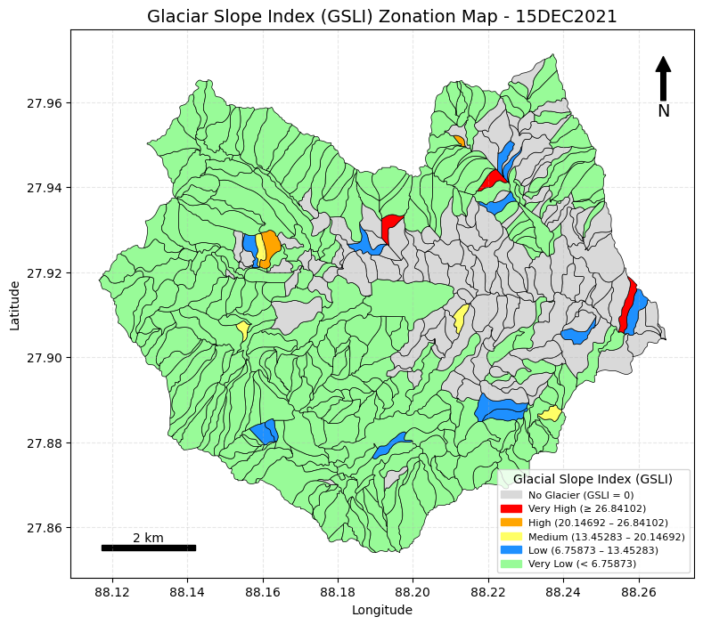  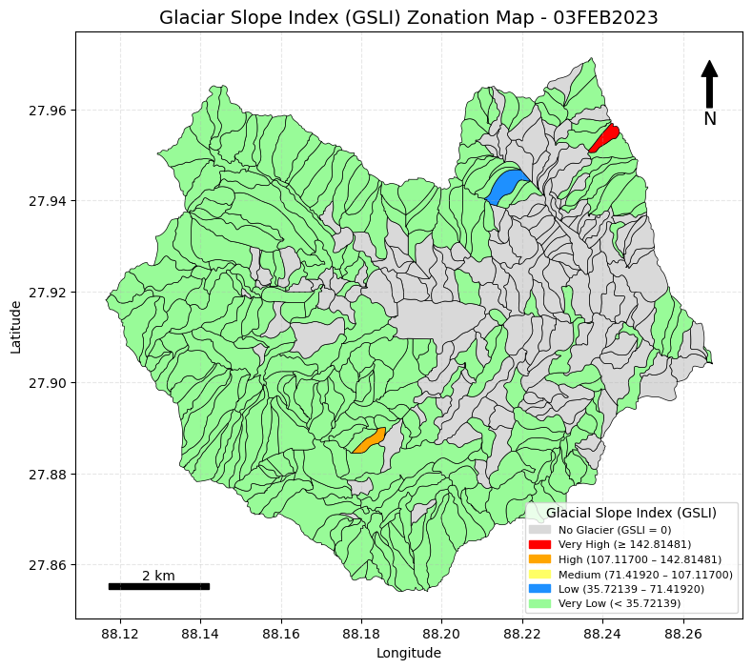 | Compute Glacier Slope Index (GSLI)  Input: watershed_L_W_parameters_ELEV_WID.geojson  Output: glacier_L_W_GSLI.geojson  Algorithms  - Read the input GeoJSON file (watershed_L_W_parameters_ELEV_WID.geojson).  - Ensure all required fields are numeric and handle missing values appropriately.  - Compute the Glacier Slope Index (GSLI) using:  GSLI=MaxE−SnoutElev / GlacialLen  - Apply the rule:  - If GlacialLen ≥ 0.1, then GSLI = 0.  - Remove any negative GSLI values, if present.  - Retain only the required attribute columns:  - W_ID  - Glacial_Len  - Max_Elev_m  - Snout_Elev_m  - GSLI  - Save the output as a GeoJSON file (glacier_L_W_GSLI.geojson).
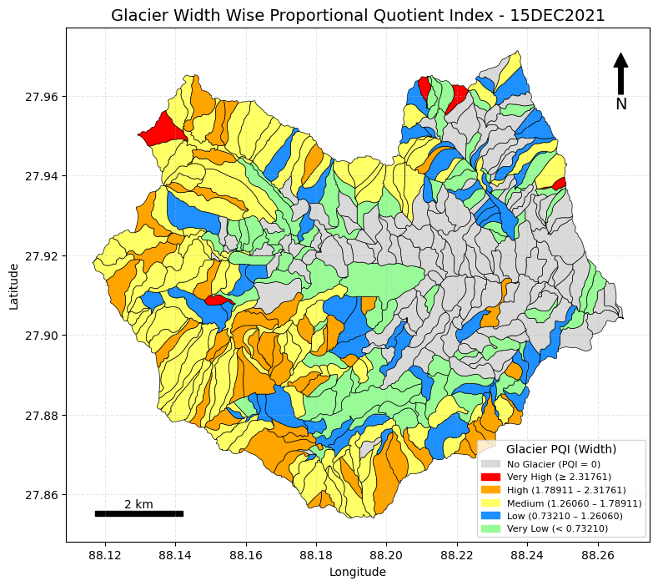  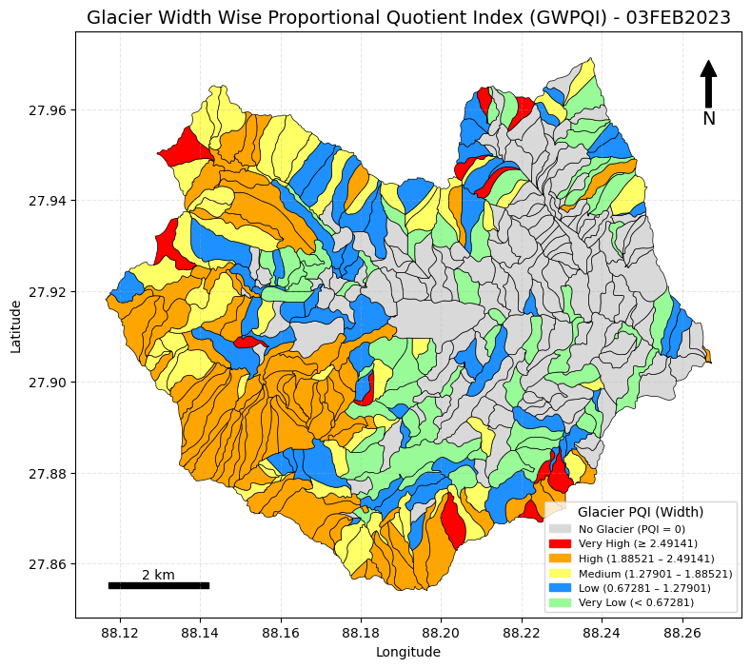  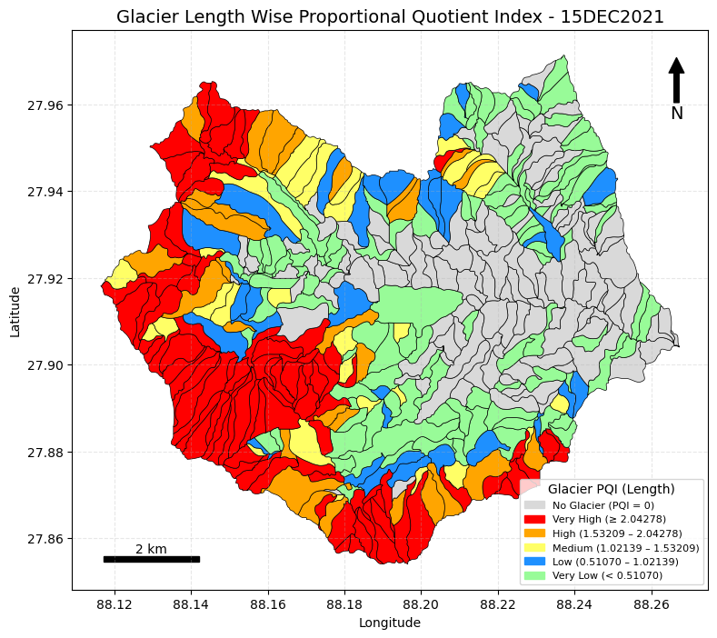  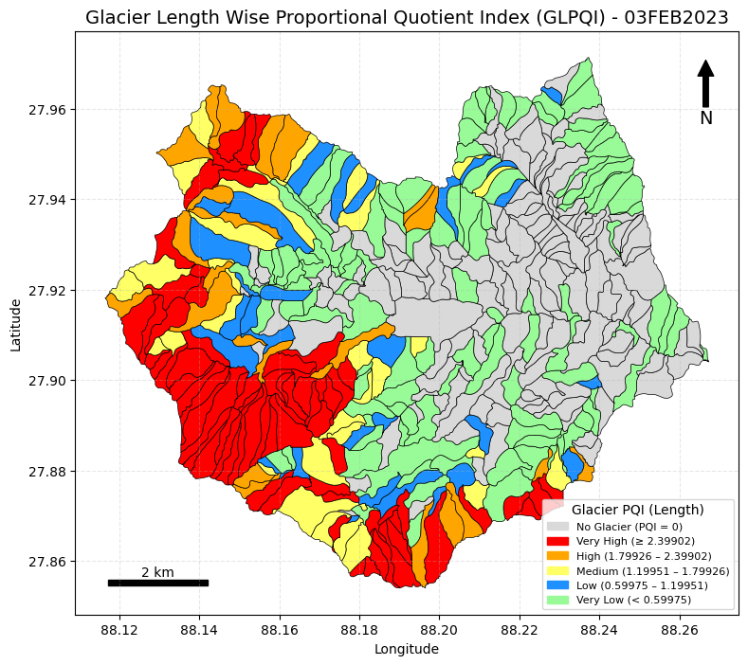 | Compute Glacier GWPQI & GLPQI  Input: watershed_L_W_parameters_WID.geojson  Output: glacier_L_W_PQI.geojson  Algorithms  - Read the input GeoJSON file (watershed_L_W_parameters_WID.geojson).  - Identify and verify required column names for glacier and watershed length and width.  - Compute global length ratio: globallengthratio = total_gl_len / total_ws_len  - Compute global width ratio: globalwidthratio = total_gl_wid / total_ws_wid  - Check for missing values:If any glacial attribute is NULL, exclude the record from PQI computation.  - Initialize output columns: PQI_Length, PQI_Width  - Compute PQI_Length for valid rows: PQI_Length = (GL_LEN / WS_LEN) / globallengthratio  - Compute PQI_Width for valid rows: PQI_Width = (GL_W / WS_W) / globalwidthratio  - Retain only valid (non-NULL) rows used in PQI computation.  - Verify PQI values are computed correctly for both length and width.  - Save the final output as GeoJSON (glacier_L_W_PQI.geojson).

Glacier Lake Morphometry
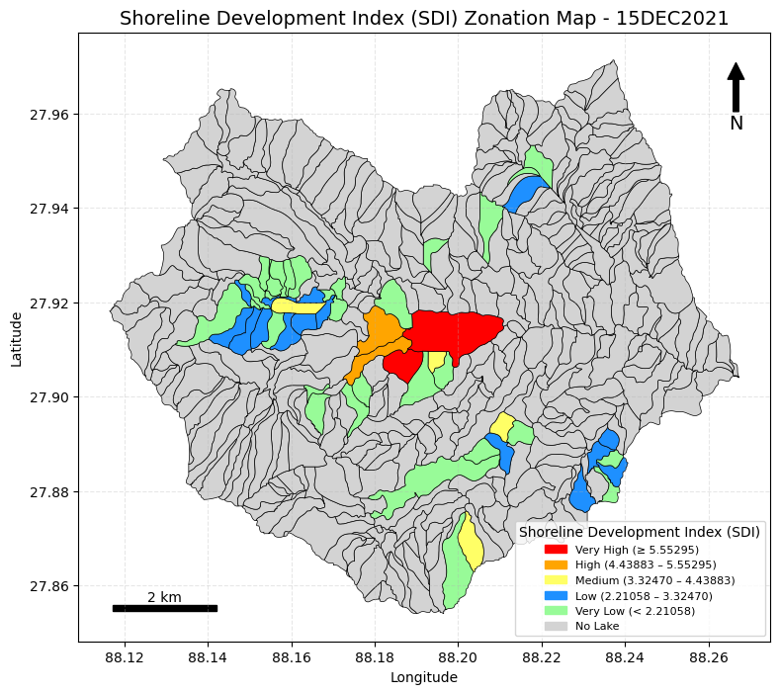  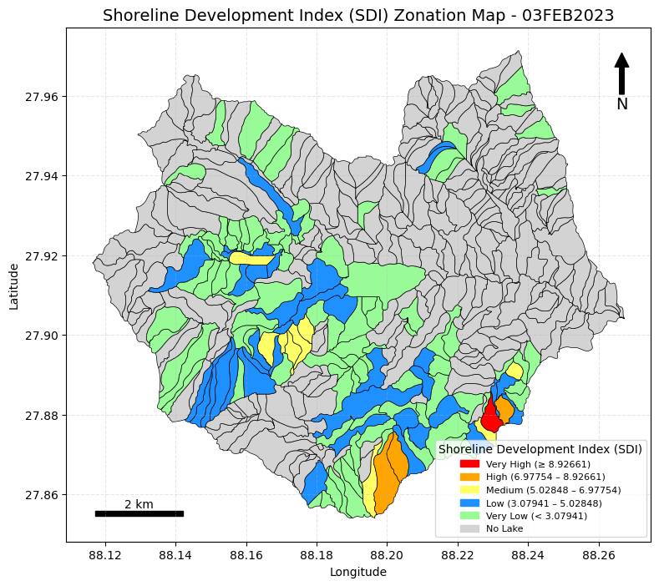 | Step 1: Compute Glacier Lake Area and Perimeter  Input: glacier_lake.geojson  Output: glacier_lakeAP.geojson  Algorithm  - Read glacier lake GeoJSON file.  - Check coordinate reference system (CRS).  - Reproject glacier lake polygons to a projected CRS (meters) for accurate area and perimeter computation.  - Compute glacier lake area in square meters (m²).  - Convert area from m² to square kilometers (km²).  - Compute glacier lake perimeter in meters (m).  - Convert perimeter from meters to kilometers (km).  - Round area and perimeter values to three decimal places.  - Add new attribute columns:  - Area_m2  - Area_km2  - Perimeter_m  - Perimeter_km  - Save the updated dataset as GeoJSON.  Step 2: Compute Shoreline Development Index (SDI) for Each Glacier Lake Segment  Input: glacier_lakeAP.geojson  Output: glacier_lakeSDI.geojson  Algorithm  - Read glacier lake area–perimeter GeoJSON.  - Ensure Area_m2 and Perimeter_m columns exist.  - Merge (dissolve) all glacier lake polygons by W_ID.  - Recalculate total area and perimeter for each merged micro-watershed.  - Compute Shoreline Development Index (SDI) using:  SDI=Perimeter_m2×π×Area_m2SDI = \frac{Perimeter\_m}{2 \times \sqrt{\pi \times Area\_m2}}SDI=2×π×Area_m2​Perimeter_m​  - Attach SDI values to corresponding W_ID.  - Retain required attributes:  - W_ID  - Area_m2  - Perimeter_m  - SDI  - Save the output as GeoJSON.  Step 3: Attach SDI with Micro-Watershed  Input: glacier_lakeSDI.geojson  watershed_UTista_selected_WID.geojson  Output: glacier_LakeSDI_W.geojson  Algorithm  - Read glacier lake SDI GeoJSON.  - Read micro-watershed boundary GeoJSON.  - Ensure both datasets have the same CRS.  - Perform attribute join using W_ID.  - Preserve original watershed geometry.  - Attach SDI and glacier lake metrics to micro-watershed polygons.  - Retain required attributes:  - W_ID  - Area_m2  - Perimeter_m  - SDI  - Save merged dataset as GeoJSON.
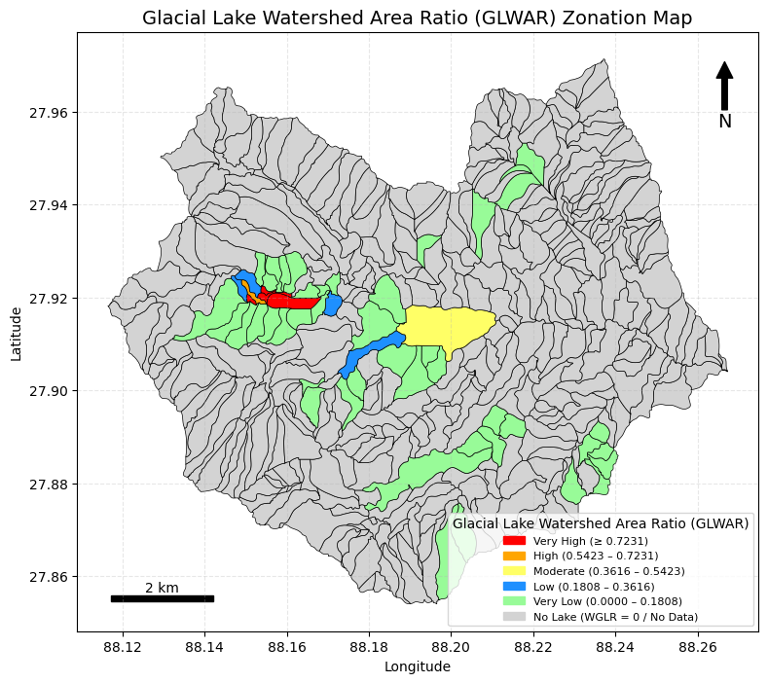  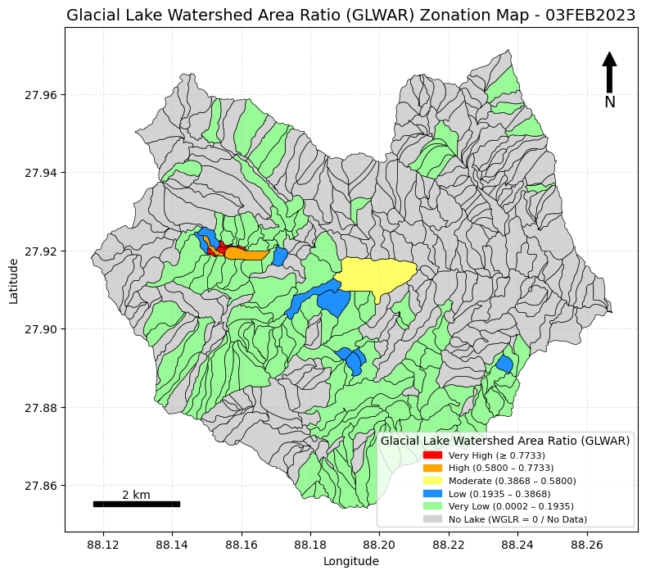 | Step 1: Intersect Glacial Lake with Micro-Watershed and Compute Area  Input  watershed_UTista_selected_WID.geojson  glacier_lake.geojson  Output  watershed_glacierlake_area.geojson  Algorithm  - Read micro-watershed boundary GeoJSON.  - Read glacier lake GeoJSON.  - Check that both layers use the same coordinate reference system (CRS).  - If CRS differs, reproject glacier lake layer using the micro-watershed CRS as reference.  - Rename watershed identifier to avoid naming conflict:  - "W_ID" → "WID_MAIN".  - Compute micro-watershed area in square meters (sqm).  - Perform spatial intersection between glacier lake polygons and micro-watershed polygons.  - Compute glacier lake area for each intersected polygon segment.  - Group intersected glacier lake segments by WID_MAIN.  - Sum glacier lake area for each micro-watershed.  - Merge glacier lake segments accordingly.  - Rename watershed identifier back:  - "WID_MAIN" → "W_ID".  - Save the result as GeoJSON.  Step 2: Compute Glacier Lake–Watershed Area Ratio (GLWAR)  Input  watershed_glacierlake_area.geojson  Output  WGLR.geojson  Algorithm  - Read watershed_glacierlake_area.geojson.  - Check that required columns exist:  - Glacier lake area  - Watershed area  - Compute Glacier Lake–Watershed Area Ratio (GLWAR) using:  GLWAR=Glacier lake area / Micro-watershed area  - Replace NaN or infinite values with 0 (optional).  - Save the output GeoJSON as WGLR.geojson.
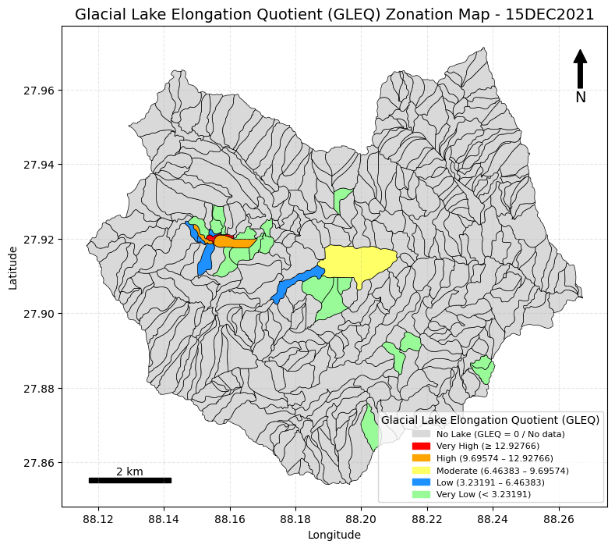  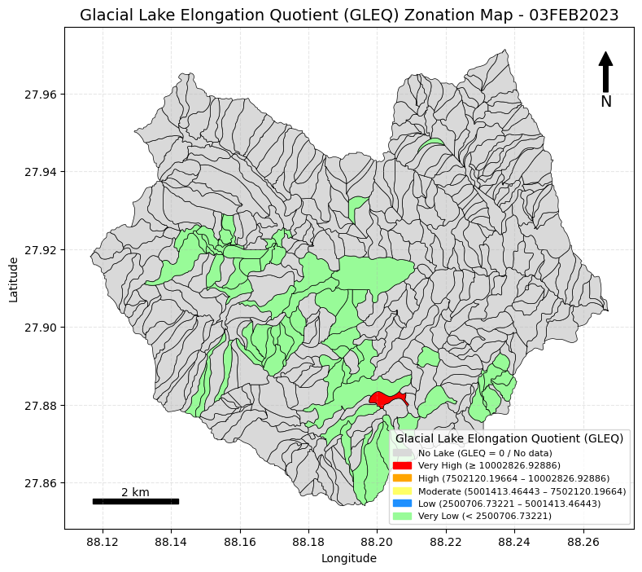 | Step 1: Intersect Micro-Watershed Centerline with Glacier Lake  Input  glacier_lake.geojson  centerline_smoothed_full.geojson  Output  lake_centerline_length_WID.geojson  Algorithm  - Read glacier lake GeoJSON.  - Read micro-watershed centerline GeoJSON.  - Keep only required attribute fields.  - Reproject both layers to a metric CRS.  - Perform spatial intersection between centerline and glacier lake polygons.  - Compute length of each intersected line segment.  - Dissolve intersected line segments by W_ID, keeping line geometry.  - Sum all seg_len_m values for each W_ID.  - Save the output as GeoJSON.  Step 2: Intersect Micro-Watershed Width with Glacier Lake  Input  glacier_lake.geojson  watershed_width_WID.geojson  Output  lake_width_clipped.geojson  Algorithm  - Read glacier lake GeoJSON.  - Read micro-watershed width GeoJSON.  - Keep only required attribute fields.  - Reproject both layers to a metric CRS.  - Perform spatial intersection between width lines and glacier lake polygons.  - Identify the correct W_ID column.  - Standardize the watershed identifier column name.  - Retain only required fields.  - Save the output as GeoJSON.  Step 3: Compute Mean Lake Width per Micro-Watershed  Input  lake_width_clipped.geojson  Output  lake_mean_width_WID.geojson  Algorithm  - Read clipped lake width GeoJSON.  - Ensure the dataset is in a metric CRS.  - Compute length of each width line.  - Calculate mean width for each W_ID.  - Create a representative geometry (one feature per W_ID).  - Save the output as GeoJSON.  Step 4: Extract Minimum and Maximum Lake Elevation  Input  glacier_lake.geojson  DEM  Output  lake_min_max_elevation_WID.geojson  Algorithm  - Read glacier lake polygons.  - Convert lake polygons into vertex points.  - Read DEM.  - Sample elevation values at each vertex.  - Remove invalid elevation values.  - Compute minimum and maximum elevation per W_ID.  - Assign representative lake geometry.  - Retain attributes:  - Lake_Min_Elev_m  - Lake_Max_Elev_m  - Save the output as GeoJSON.  Step 5: Join All Lake and Micro-Watershed Parameters  Input  - watershed_UTista_selected_WID.geojson  - Wcenterline_length_computed.geojson  - watershed_widthmean.geojson  - lake_centerline_length_WID.geojson  - lake_mean_width_WID.geojson  - lake_min_max_elevation_WID.geojson  Output  glacial_lake_L_W_all_parameters.geojson  Algorithm  - Read micro-watershed boundary GeoJSON.  - Read micro-watershed length table.  - Read micro-watershed width table.  - Read lake length table.  - Read lake mean width table.  - Read lake elevation table.  - Standardize attribute names across all datasets.  - Merge all attribute tables using W_ID.  - Handle missing or null values.  - Save final merged dataset as GeoJSON.  Step 6: Compute Glacier Lake Elongation Ratio (GLEQ)  Input  glacial_lake_L_W_all_parameters.geojson  Output  glacial_lake_L_W_GLEQ.geojson  Algorithm  - Read glacier lake length–width parameter GeoJSON.  - Ensure all required fields are numeric.  - Compute Glacier Lake Elongation Ratio (GLEQ) using:  GLEQ=Lake_Length_m/ Lake_Mean_Width_m  - Apply rule:  - If Lake_Length_m == 0 or Lake_Mean_Width_m == 0, set GLEQ = 0.  - Retain required attributes:  - W_ID  - Lake_Length_m  - Lake_Mean_Width_m  - GLEQ  - geometry  - Save the output as GeoJSON.
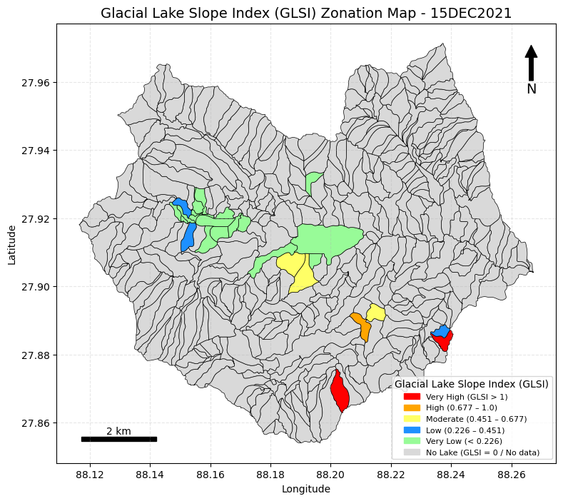  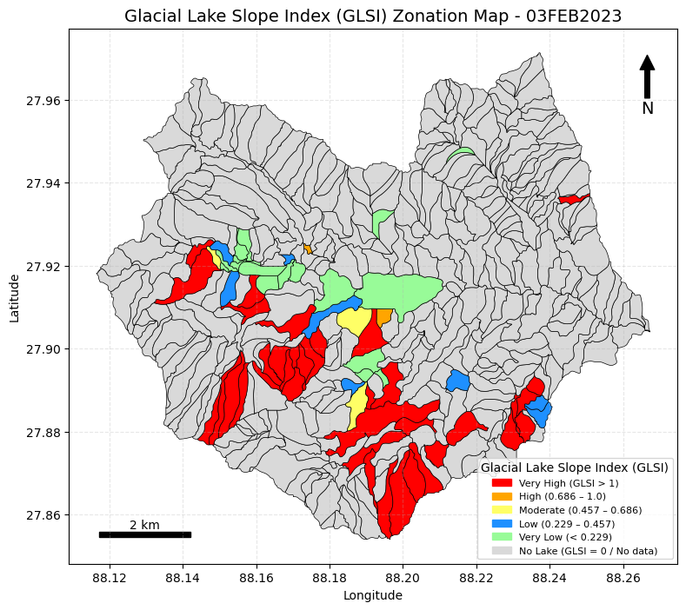 | Compute Lake Slope Index (GLSI)  Input file:  glacial_lake_L_W_all_parameters.geojson  Output file:  glacial_lake_L_W_GLSI.geojson  Algorithms  - Read Input Data  Read the GeoJSON file glacial_lake_L_W_all_parameters.geojson.  - Ensure Numeric Values & Handle Missing Data  Convert required columns to numeric values.  Handle missing or invalid values appropriately.  - Check Required Columns Exist  Ensure the following fields are present:  - W_ID  - Lake_Length_m  - Lake_Min_Elev_m  - Lake_Max_Elev_m  - Initialize GLSI Column  Create a new column named GLSI.  - Apply Length Rule  - If Lake_Length_m < 0.1 → set GLSI = 0  - If Lake_Length_m ≥ 0.1 → GLSI is eligible for computation  - Compute Lake Longitudinal Slope Index (GLSI)  Use the equation:  GLSI=Lake_Max_Elev_m−Lake_Min_Elev_mLake_Length_mGLSI = \frac{Lake\_Max\_Elev\_m - Lake\_Min\_Elev\_m}{Lake\_Length\_m}GLSI=Lake_Length_mLake_Max_Elev_m−Lake_Min_Elev_m​  - Remove Negative GLSI Values  If any computed GLSI value is negative, replace it with 0.  - Keep Only Required Output Columns  Retain the following fields only:  - W_ID  - Lake_Length_m  - Lake_Min_Elev_m  - Lake_Max_Elev_m  - GLSI  - Save Output File  Save the final GeoJSON as:  glacial_lake_L_W_GLSI.geojson
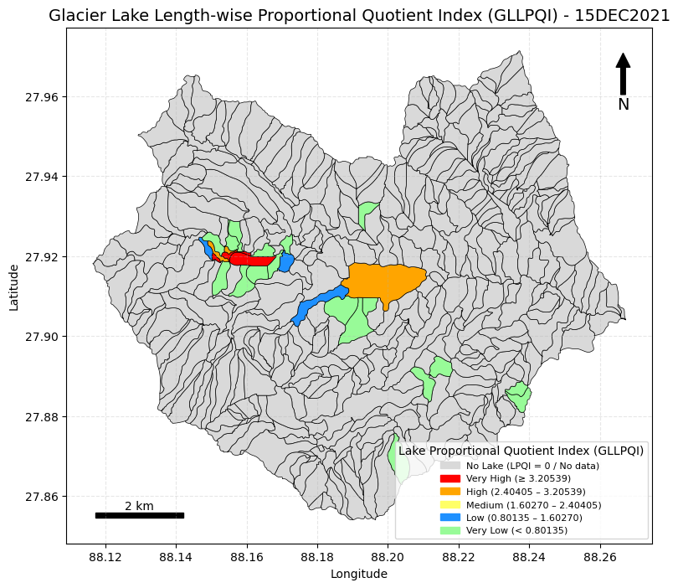  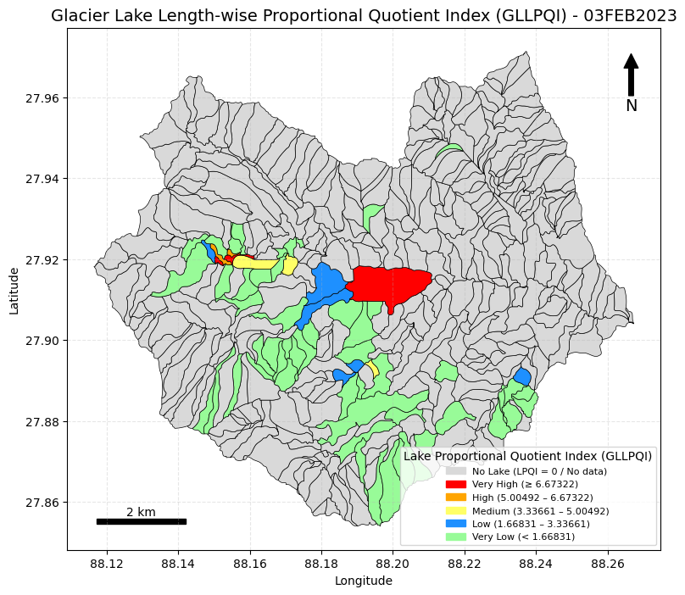  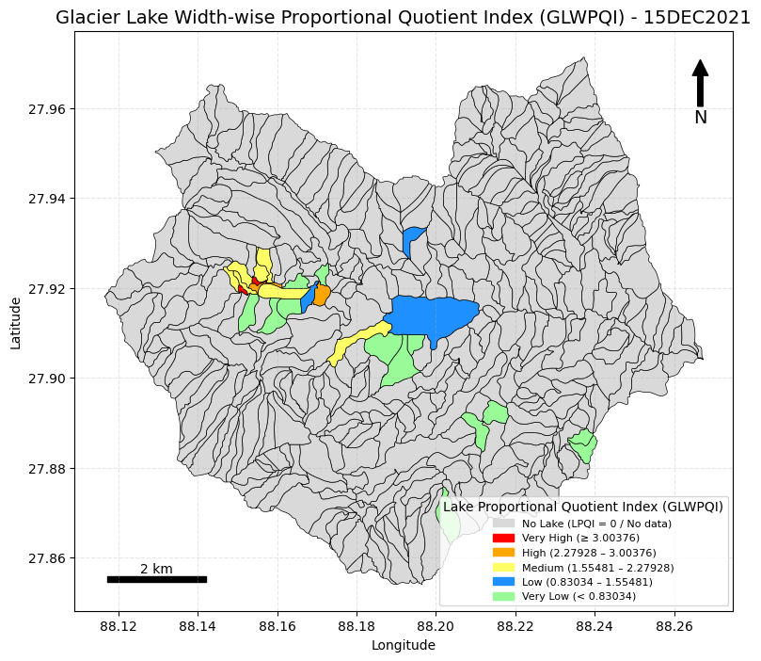  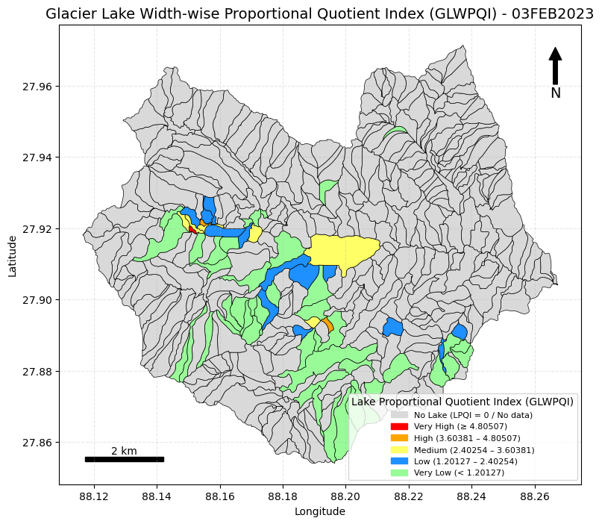 | Compute Glacial Lake Length–Width PQI (GLLPQI & GLWPQI)  Input file:  glacial_lake_L_W_all_parameters.geojson  Output file:  glacial_lake_L_W_PQI.geojson  Algorithms  - Read Input Data  Read the GeoJSON file glacial_lake_L_W_all_parameters.geojson.  - Display and Verify Column Names (Lake & Watershed)  Ensure required columns for:  - Lake Length (LK_LEN)  - Lake Width (LK_WID)  - Watershed Length (WS_LEN)  - Watershed Width (WS_WID)  - Compute Global Ratios (Ignore NULL Values)  - Compute total lake length:  total_lk_len = sum of all LK_LEN  - Compute total watershed length:  total_ws_len = sum of all WS_LEN  - Compute total lake width:  total_lk_wid = sum of all LK_WID  - Compute total watershed width:  total_ws_wid = sum of all WS_WID  - Compute Global Length and Width Ratios  - global_len_ratio = total_lk_len / total_ws_len  - global_wid_ratio = total_lk_wid / total_ws_wid  - Strict NULL Check  - If any lake-related attribute is NULL, do not compute PQI for that record.  - Initialize Output Columns  - LPQI_Length  - LPQI_Width  - Select Valid Rows Only  Valid rows must satisfy:  - LK_LEN > 0  - LK_WID > 0  - WS_LEN > 0  - WS_WID > 0  - global_len_ratio > 0  - global_wid_ratio > 0  - Compute LPQI for Valid Rows  - LPQI_Length  LPQILength=(LK_LEN/WS_LEN) / global_len_ratio  - LPQI_Width  LPQIWidth=(LK_WID/WS_WID) / global_wid_ratio​  - Zero Rule  - If either LPQI_Length or LPQI_Width is zero, then set both to zero.  - Save Output  Save the final GeoJSON as:  glacial_lake_L_W_PQI.geojson

Catchment Morphometric parameters

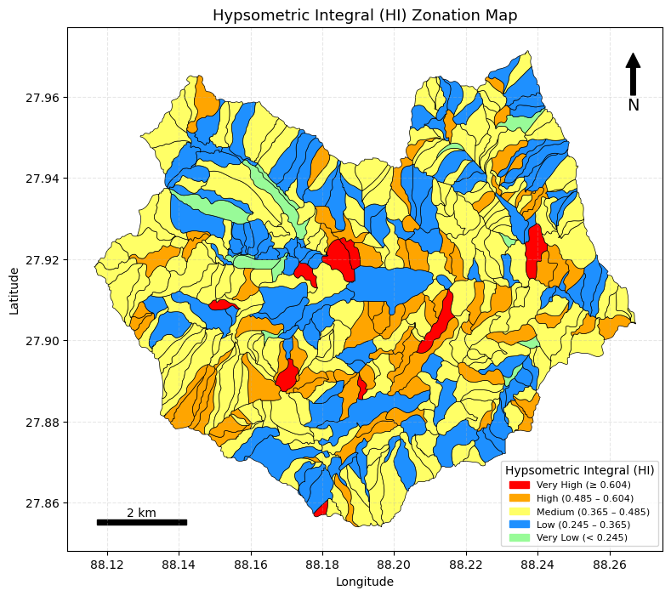 | Step 1: Extract Elevation Statistics for Micro-Watershed  Input  - Micro-watershed polygon (MWatershed)  - DEM  Output  - Watershed_catchment_relief.geojson  Algorithm  - Read micro-watershed polygon dataset.  - Read DEM.  - Check CRS of micro-watershed and DEM.  - If CRS does not match DEM, reproject micro-watershed to DEM CRS.  - Perform zonal statistics on DEM for each micro-watershed.  - Extract elevation statistics:  - Minimum elevation  - Maximum elevation  - Mean elevation  - Store extracted elevation statistics with corresponding W_ID.  - Save the output as GeoJSON.  Step 2: Compute Hypsometric Index (HI)  Input  - Watershed_catchment_relief.geojson  Output  - Catchemnt_Hypsometric_Index.geojson  Algorithm  - Read Watershed_catchment_relief.geojson.  - Select required columns:  - W_ID  - Mean_Elev  - Min_Elev  - Max_Elev  - Compute Hypsometric Index (HI) using:  HI=Mean_Elev−Min_Elev / Max_Elev−Min Elev ​  - Save the output as GeoJSON.
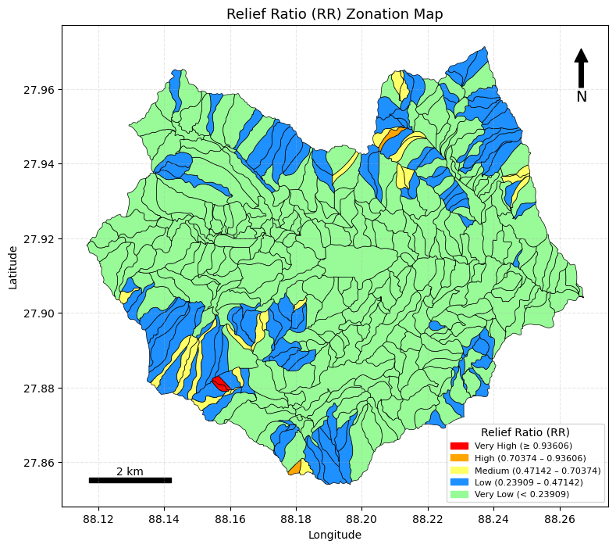 | Compute Relief Ratio (RR)  Input: Watershed_catchment_relief.geojson  Output: catchment_relief_ratio.geojson  Algorithms  - Read the catchment GeoJSON file (Watershed_catchment_relief.geojson).  - Reproject the catchment geometry to UTM Zone 45N to ensure accurate metric calculations.  - Compute the area of the catchment in square meters (m²).  - Compute the Relief Ratio (RR) using:  RR={(MaxE−MinE) / Area}×100  - Select only the required output attribute fields.  - Save the output GeoJSON as catchment_relief_ratio.geojson.
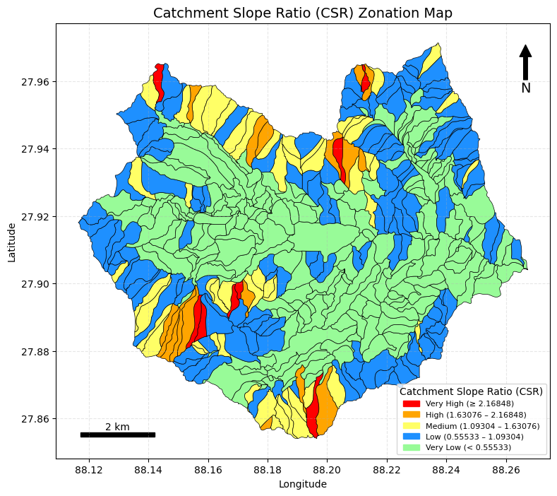 | Step 1: Create Centreline of Micro-Watershed  Input  DEM  Micro-watershed polygon (MWatershed)  Output  centerlines_final.geojson  Algorithm  - Read DEM and micro-watershed polygon.  - Create a polygon mask for each micro-watershed.  - Convert polygon mask to raster mask.  - Apply skeletonization on the mask (mask > 0).  - If skeleton is too small, apply fallback method.  - Convert skeleton pixels to geographic coordinates.  - Sort skeleton coordinates by distance to approximate the centreline.  - Mask DEM with the watershed polygon.  - Generate centreline for each micro-watershed.  - Attach corresponding W_ID.  - Save all centrelines as GeoJSON.  Step 2: Extract Vertex Elevation of Centreline  Input  centerlines_final.geojson  DEM  Output  Vertex elevation dataset (GeoJSON)  Algorithm  - Read centreline GeoJSON.  - Read DEM.  - Extract vertices from centreline geometry:  - Case 1: LineString  - Case 2: MultiLineString  - Create a vertex GeoDataFrame.  - Reproject vertices to DEM CRS if required.  - Prepare coordinate list from vertex points.  - Sample DEM elevation at each vertex.  - Attach elevation values to vertices.  - Save vertex elevation dataset.  Step 3: Create LineString from Ordered Elevation Points  Input  centerline_vertices_elevation.geojson  Output  centerline_ordered_by_elevation.geojson  Algorithm  - Read vertex elevation GeoJSON.  - Process vertices watershed-wise using W_ID.  - Convert vertex coordinates and elevations to NumPy arrays.  - Identify the lowest elevation point.  - Compute full distance matrix between points.  - Iteratively select the nearest point with higher elevation.  - Exclude points with lower elevation.  - Append selected points sequentially.  - Construct LineString from ordered points.  - Save the ordered centreline as GeoJSON.  Step 4: Extend Centreline to Watershed Boundary  Input  centerline_ordered_by_elevation.geojson  Micro-watershed polygon  Output  centerline_extended.geojson  centerline_extended_corrected.geojson  Algorithm  - Read ordered centreline GeoJSON.  - Read micro-watershed polygon.  - Identify watershed containing each centreline (using midpoint).  - Extend centreline to intersect watershed boundary.  - Smooth the extended centreline.  - Save extended centreline.  - Apply geometric correction.  - Save corrected centreline as GeoJSON.  Step 5: Measure Centreline Length  Input  Extended centreline GeoJSON  Output  Centreline length values (attribute)  Algorithm  - Read centreline file.  - Reproject to UTM Zone 45N (meters).  - Measure centreline length in meters.  - Store length as an attribute.  Step 6: Compute Basin Length per Micro-Watershed  Input  centerline_smoothed_full.geojson  watershed_UTista_selected_WID.geojson  Output  watershed_with_basin_length.geojson  Algorithm  - Read smoothed centreline GeoJSON.  - Read micro-watershed boundary GeoJSON.  - Reproject both layers to UTM Zone 45N.  - Group centreline segments by W_ID.  - Sum length of all line segments per W_ID.  - Join basin length values to watershed polygons.  - Save output GeoJSON.  Step 7: Join Elevation and Basin Length Parameters  Input  Watershed_Elevation_Area_Stats.geojson  watershed_with_basin_length.geojson  Output  Watershed_catchment_relief.geojson  Algorithm  - Read watershed elevation–area statistics file.  - Read watershed basin length file.  - Verify presence of W_ID in both datasets.  - Select only W_ID and basin length column.  - Join elevation and basin length datasets using W_ID.  - Save combined GeoJSON.  Step 8: Compute Catchment Slope Index (CSI / CSR)  Input  Watershed_catchment_relief.geojson  Output  catchment_slope_CSI.geojson  Algorithm  - Read catchment relief GeoJSON.  - Reproject to UTM Zone 45N for accurate length measurement.  - Use basin length (basin_length_m) as catchment length.  - Compute Catchment Slope Index (CSI):  CSI=MaxE−MinE / basin_length  - Select required output fields.  - Save output GeoJSON.
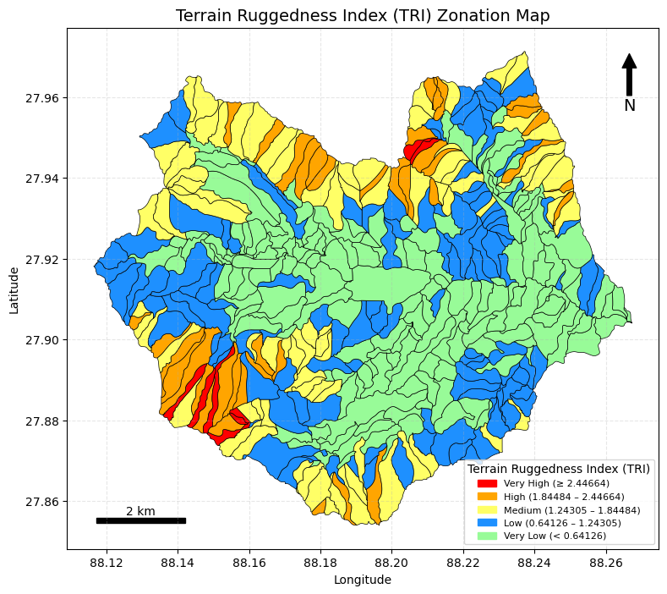 | Compute Terrain Ruggedness Index (TRI)  Input: Watershed_catchment_relief.geojson  Output: catchment_terrain_ruggedness.geojson  Algorithms  - Read the catchment GeoJSON file (Watershed_catchment_relief.geojson).  - Reproject the catchment geometry to UTM Zone 45N to ensure accurate metric calculations.  - Compute the area of the catchment in square meters (m²).  - Compute the Terrain Ruggedness Index (TRI) using:  TRI= ((MaxE−MinE) / sqrt Area)×100  - Select only the required output attribute fields.  - Save the output GeoJSON as catchment_terrain_ruggedness.geojson.
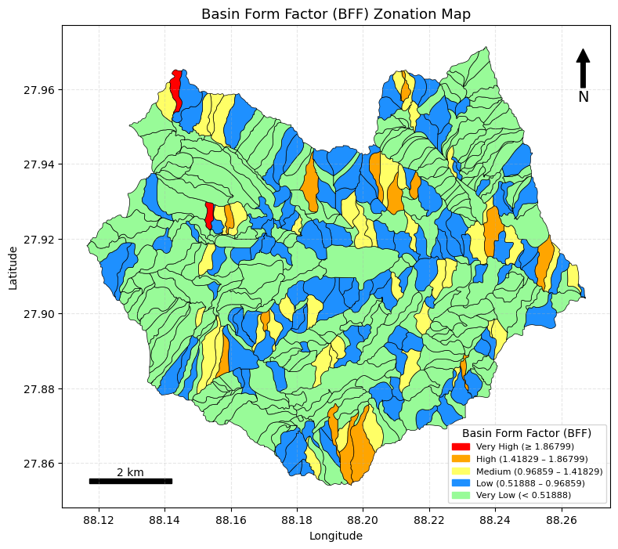 | Compute Basin Form Factor (BFF)  Input: Watershed_catchment_relief.geojson  Output: catchment_form_factor_index.geojson  Algorithms  - Read the catchment GeoJSON file (Watershed_catchment_relief.geojson).  - Reproject the catchment geometry to UTM Zone 45N to ensure accurate length measurement.  - Compute the area of the catchment in square meters (m²).  - Compute the Basin Form Factor (BF) using:  BF=Area / (Length)²​  - Select only the required output attribute fields.  - Save the output GeoJSON as catchment_form_factor_index.geojson.

